Wastewater Collections Practice Problems
These are not intended to be exact problems from any state exam. Simply memorizing the questions won’t help. This is to help get used to doing the different types of word problems. SORRY, THINKING IS STILL REQUIRED.

For a little bit more in-depth detail on how to work out some Collection Math problems and Theory questions, look at “COLLECTION BOOK 2007.pdf” and ”Collections Theory Auto Test.xls” found elsewhere on this site. Any problems, suggestions or questions e-mail me. sewergeek@cox.net

To use this spreadsheet;

1) Double-Click on a question. The table outline will appear.
2) Work out the problem, pick the answer box and place an ‘x’ in the box, Press ENTER.

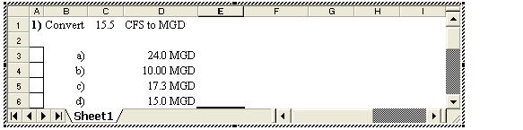

X
3) You will be told if your answer is right or wrong. There is also an answer key on the last page.
This key works for all of my Collection study material.

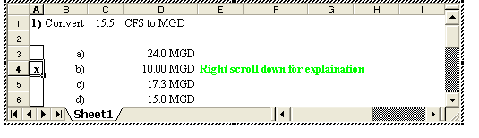
4) Grab the dot at the bottom of the frame with the mouse arrow. Click & drag the window open to
reveal the solution. OR use the mouse wheel to scroll down.
5) You can Press the TAB key to jump to the different numbers and change them to create an unlimited
amount of practice questions. ONLY TYPE THE NUMBERS. The units, (feet, MGD Ft^{.3}, etc) will
automatically format themselves.

The answers choices AND the solutions that you scroll down to, will re-work themselves out.
Some questions have drop-down boxes that you can pick to change certain words. This will change the questions. They will have different answers and different meaning.

Click on the choices to re-write the question

Please set the printer to ‘Print current page” when printing sample questions. This document is very large and can waste a lot of paper by printing all of it accidentally. If this document gets out of hand, close it without saving & open it up again.

This is write-protected, so you should not be able to mess it up. If you do, just send me an e-mail & I will load a back-up version. It will only allow you to type over certain things & you can’t save it except under a new name.

MISC ADD-ON QUESTIONS:

